Ryan Magante
CS: 320
2/22/2026
Project Two
In Project one, my unit testing approach was requirements-driven, meaning that each test case directly corresponded to a specific functional constraint. For the Contact, Task, and Appointment features, validation rules such as maximum character lengths, non-null identifiers, uniqueness enforcement, and restrictions on past appointment dates were implemented in constructors and service methods. These rules were verified through both positive tests confirming valid object creation and negative tests ensuring that invalid input triggered IllegalArgumentException. By embedding validation within constructors and services directly testing those branches, the implementation remained tightly aligned with the stated software requirements.
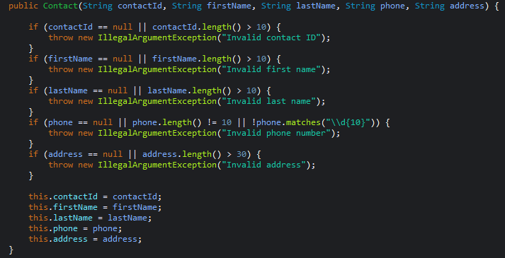
Negative Testing played a central role in verifying requirement enforcement. Rather than assuming validation logic functioned correctly, I used assertThrows() to confirm that invalid inputs, like null fields long strings or duplicate identifiers, produced controlled failures. These tests exercised boundary conditions and invalid partitions to ensure that improper data could not enter the system. By deliberately constructing failure scenarios, the test validated that requirement constraints were actively enforced rather than passively defined.
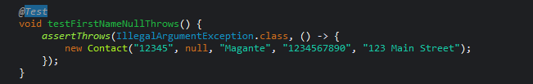
Coverage analysis further demonstrated test effectiveness. Model classes such as Task and Appointment achieved 100% coverage, while Contact reached 96.8%. Service-layer classes also showed strong coverage, including 94.6% for TaskService and 100% for AppointmentService, with Contact Service at 82.5%. These results indicate that both successful execution paths and conditional branches were exercised. For example, duplicate-ID checks using Map.containsKey(id) and appointment date validation were explicitly tested through corresponding failure cases. High coverage therefore reflects deliberate branch testing rather superficial verification of expected outputs.
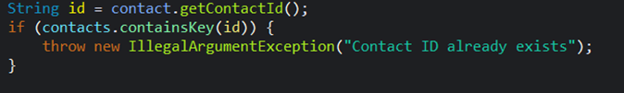
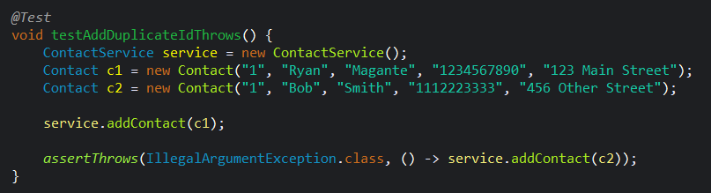
Beyond coverage, I applied several strategies to ensure the code itself was technically sound and maintainable. Validation logic was placed directly within constructors to prevent invalid objects from being instantiated, while service classes were responsible only for orchestration tasks such as managing collections and enforcing uniqueness. For example, in the Appointment class, a defensive copy of the Date object is created to preserve immutability and prevent external modification of internal state.
Additionally, identifiers were declared as final where appropriate to prevent unintended reassignment. This separation of responsibilities, combined with explicitiy exceptions handling and clearly defined public methods, reduced complexity and ensured that validation rules were enforced consistently at the object level rather than scattered throughout the application.
In addition to being technically sound, the implementation was designed with efficiency in mind. Service classes utilize a HashMap to store objects, enabling near constant-time lookups through containsKeys() and direct key access. This approach avoids the need for iterative searches that would be required if a list structure were used. This approach also improves scalability as the number of stored objects increases. By leveraging the underlying hash algorithm for identifier management, duplicates checks and retrieval operations remain efficient even as the dataset grows. Furthermore, update methods delegate validation to the model classes rather than duplicating logic at the service layer, reducing redundant code and improving maintainability. These design decisions ensure that the system remains clean as complexity increases.
In completing this project, I applied multiple software testing techniques beyond basic unit testing. At a foundational level, the approach reflects black-box testing because validation was derived directly from written specifications rather than assumptions. At the same time, white-box principles were applied by deliberately exercising conditional branches within constructors and service methods. Boundary value analysis was used when testing maximum field lengths, ensuring that inputs at the allowed limit were accepted while values exceeding that limit were rejected. Decision testing was evident in-service layer logic, where duplicated-ID checks and null validations required both true and false outcomes. Additionally, regression testing occurred each time the full suite was re-executed after modifications, ensuring that new changes did not break previously validated functionality.
While this project focused on isolated components, broader techniques such as integration, system, and load testing would be necessary in larger-scale applications to evaluate interactions, full-system behavior, and performance under stress. Writing tests for one’s own code can also introduce confirmation bias, so intentionally constructing failure cases helped ensure validation was objective. Consistent automated testing ultimately reduces technical debt and supports long-term software reliability.

